### 

### 

### 

**IND ENG 190E**

**Group 11 Proposal**

**Walk-In-The-Park**

Oh Zhe Hao

Joseph Teo

Kok Hui Yuan

Lock Yin Tam

Vienna Neo

### 

### 

### 

### 

### **Work Plan:**

This is the timeline that we came up with for this project.

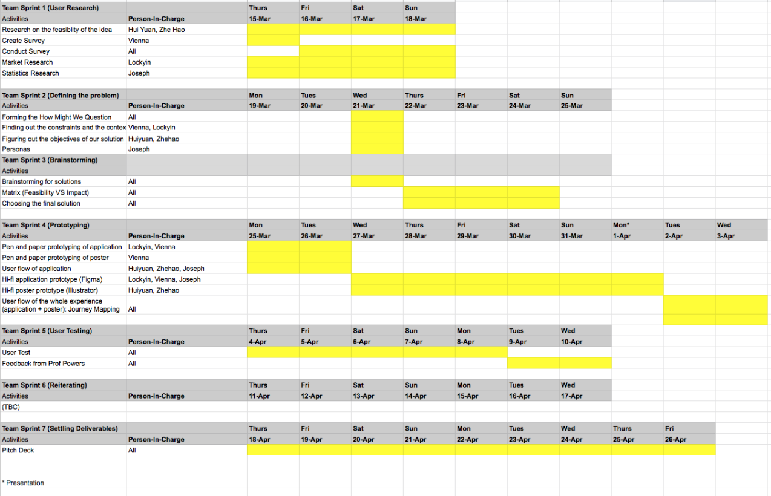

Figure 1: Excel sheet of work plan

### **Assumption & Experiment Spreadsheet:**

### For our user research, we chose to do a survey to better understand our target audience and validate the assumptions that we made. The assumptions that surfaced includes:

1. The current street parking experience is problematic and can be improved on.
2. Current street parking signs are difficult to read
3. Drivers would rather pay using an application than using coins
4. Fines are common due to reasons like misunderstanding signs that could be avoided
5. Drivers take a long time to look for street parking in busy cities

### For the survey, we wanted to get a large pool of people to gather important statistics and data. The objectives of our survey is to find out:

1. If fines due to street parking are common and the cause of these fines
2. On average the time taken for a driver to find a suitable parking spot
3. The difference between drivers current paying method for street parking and their preferred paying method
4. The pain points that drivers faced when looking and parking at a street parking spot.

We used the following questions to gather our data:

1. How do you usually find street parking?
   1. Drive around the area and look for available lots
   2. Use some application
      1. What application do you use?
   3. Others
2. Have you ever gotten a fine from street parking?
   1. Yes
      1. Why did you get a fine? (Click all that applies)
         * I chose to park at an area where I knew was illegal
         * I didn't read the parking rules carefully
         * I parked for a longer period of time than what I paid for
         * Others
   2. No
3. How do you usually pay for street parking?
   1. Insert coins in meter
   2. Use credit card/debit card
   3. Use the application attached to the meter
4. Rank the different ways that you would PREFER to pay for street parking:
   1. Insert coins in meter
   2. Use credit card/debit card
   3. Use the application attached to the meter
5. On average, how long do you usually take to find suitable street parking?

1 to 20 minutes slider

1. Are there any particular pain points/ frustrations that you faced while parking at street parking (Click all that applies)
   1. Can't find available parking easily
   2. Confusing parking signs
   3. Unclear pricing system
   4. Unable to estimate how long you should pay for
   5. Others
2. How do you think the street parking experience can be improved?

Open ended

Gathering data from around 30 respondents, we gathered some important data that validated our assumption and helped us to form our problem statement:

1. 90% of respondents do not use the help of an application or any data online to find for parking spots and simply just drive around till they find one
2. 43% of respondents have gotten a fine from street parking
3. 31% of respondents got that fine from parking at a spot that he knew was illegal to, 38% of respondents did not read the parking signs carefully, 31% of respondents parked for a longer period of time than what he paid for
4. Currently, only 10% of respondents use an application to pay for street parking but 73% of respondents would prefer to use an application rather than paying using coins
5. On average, respondents take 10.58 minutes to find a street parking lot.
6. The pain points stated in the survey were all pain points that at least 30% of respondents face.
7. The word cloud for question 7 showed us that an application was a popular suggestion.

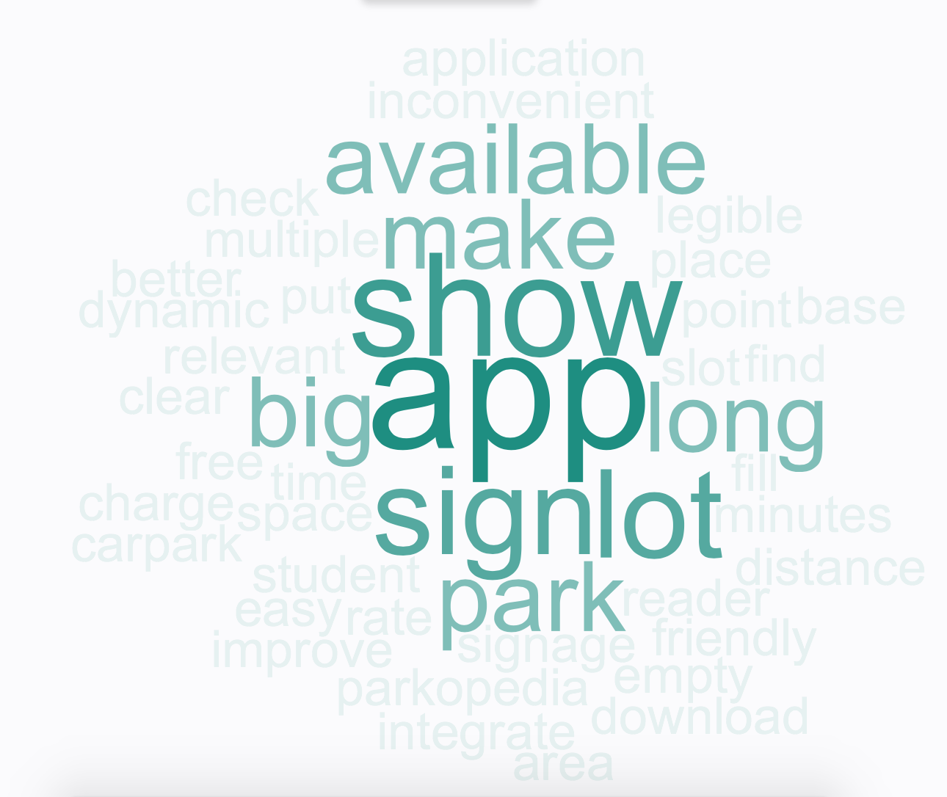

Figure 2: Word Cloud for Survey Question No. 7

1. Certain quotes from respondents that stood out includes “Same application for parking as different areas use different applications and it is quite inconvenient to have to download multiple apps”, “The parking signs could be bigger/more legible from a distance.”, “Use dynamic signs to show lot availability”, “Bigger and clearer signages”

### **Problem Statement:**

### After researching more about the issue and framing our problem, the problem statement that we came up with is “How might we improve the street parking experience for drivers in busy cities in America?”. We wanted to target street parking as we found a large number of fines come from street parking and that it was a problematic area that could be improved upon. Furthermore, we found that this issue is more pertinent in busy cities like San Francisco, Los Angeles and New York City where street parking are often very limited.

### **Total Addressable Problem:**

### Based on the survey and the one-to-one interviews that we did, we found that there were three main problems that we could tackle and improve on:

1. Street parking signs are often confusing and difficult to understand
2. Drivers often take a long time (average = 10.58 minutes) to look for a suitable street parking lot around busy cities
3. Drivers often face the issue of not being able to accurately estimate the time they need to park for, resulting in fines or money wastage

The main goal and idea of our project is to dig deeper into these problems, alleviate the pain points and improve the street parking experience for drivers. Based on the findings of our user research, we found that this problem is definitely one that drivers face on a daily basis in busy cities and is one that can be improved on.

### **Value Proposition:**

### We aim to design a product that streamlines the parking experience for the average driver. The product would enable the user to seamlessly find, navigate, and pay for parking. It would offer the user a peace of mind and allow the user to concentrate on his/her task at hand, be it a leisure family trip or an urgent conference meeting.

### 

### 

### 

### 

### 

### **Empathy Map:**

This is the empathy map that we came up with based on our user research:

### 

Figure 3: Empathy Map

**Personas:**

After surveying drivers and taking into account our survey results, we created 2 different personas which describe the characteristics of the users our solution is trying to target.

Persona 1 (Experienced driver but hates wasting time):

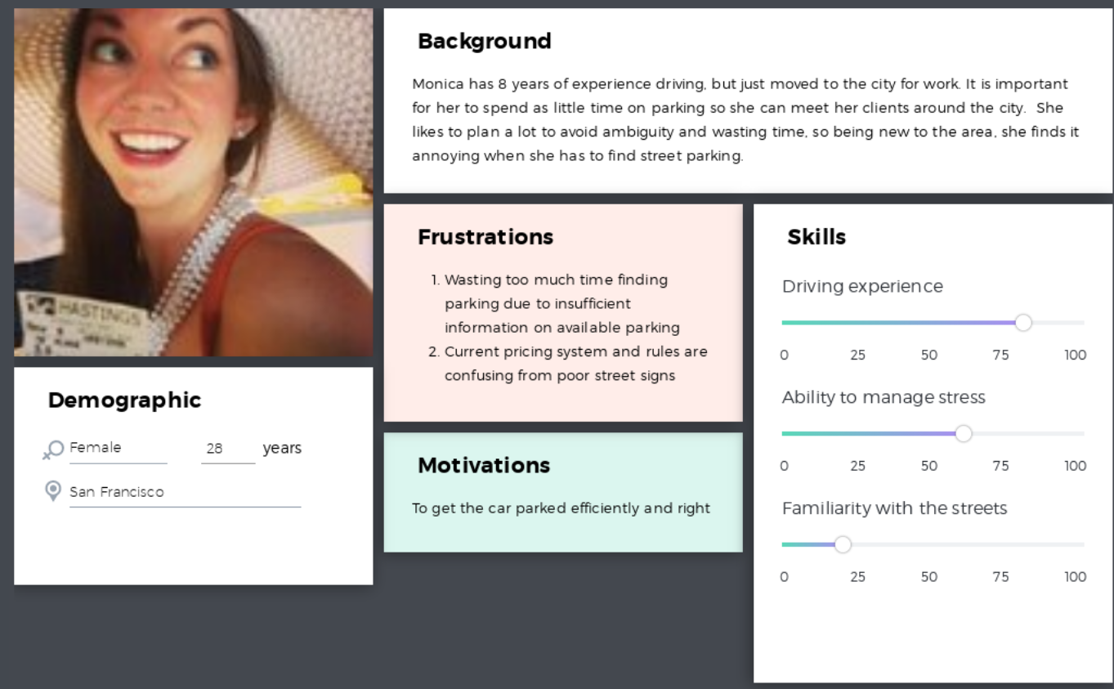

Figure 4: Persona 1

Persona 2 (Inexperienced driver who cannot manage stress effectively):

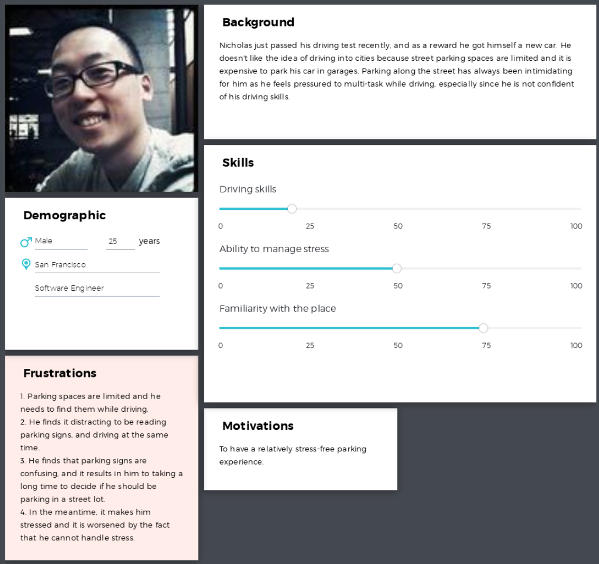

Figure 5: Persona 2

**Conceptual Map:**

Initial user flow of parking experience

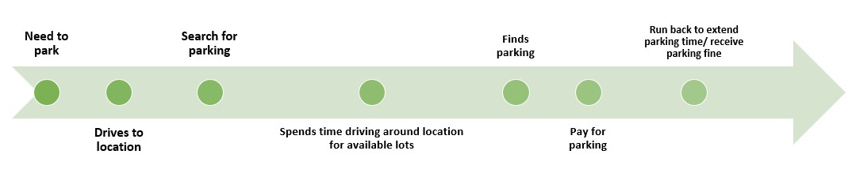

The typical user flow of parking consists of several pain points and time consuming steps that can potentially be eliminated.

Final user flow of streamlined parking experience

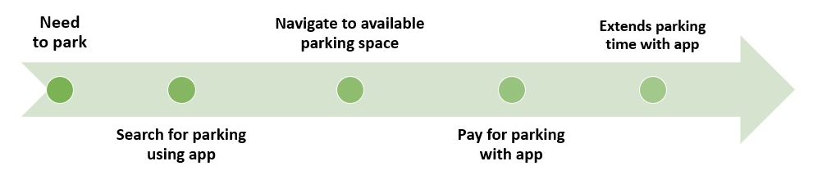

The final user flow is intended to be greatly simplified and targeted at ensuring the user has a non-obtrusive parking experience.

### **Concept Sketches:**

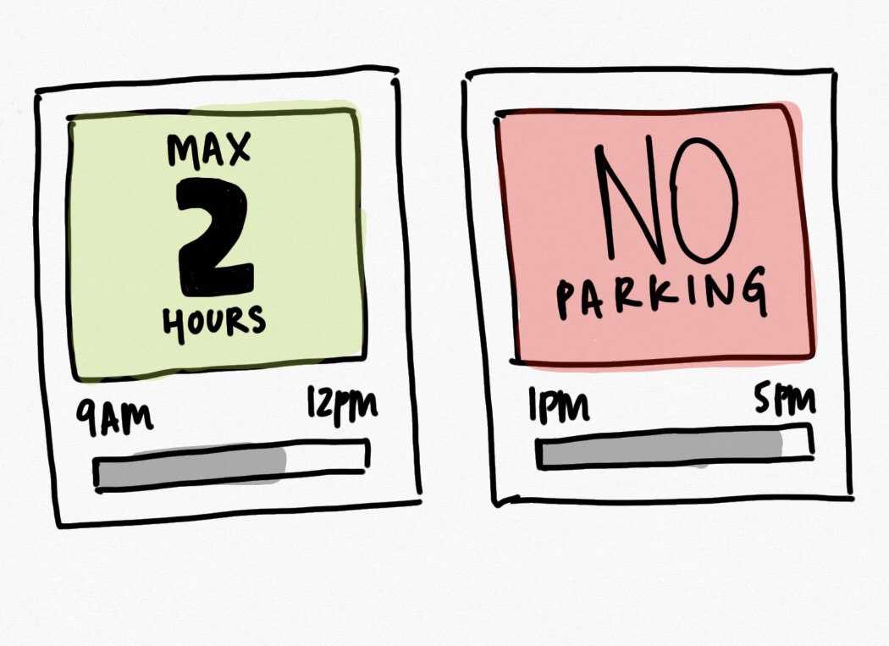

Figure 6: Initial concept sketch for digitalized street parking signs

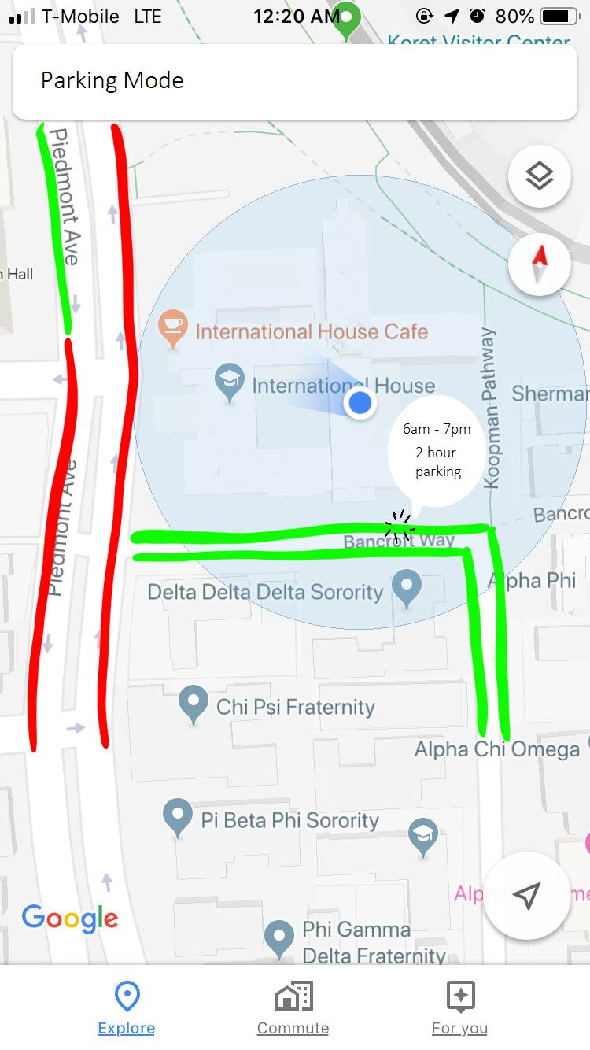

Figure 7: Initial concept sketch of how our app would look like

**Prototyping:**

### Application:

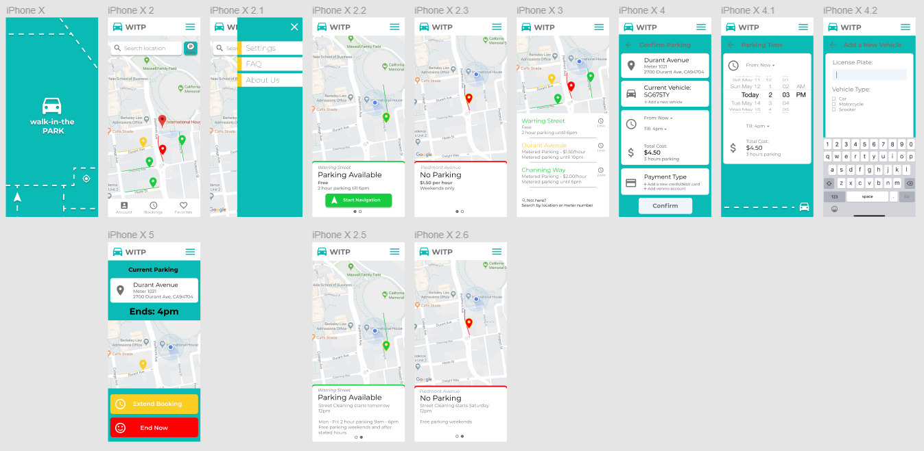

Figure 8: Final Prototype on Figma

Parking Signs:

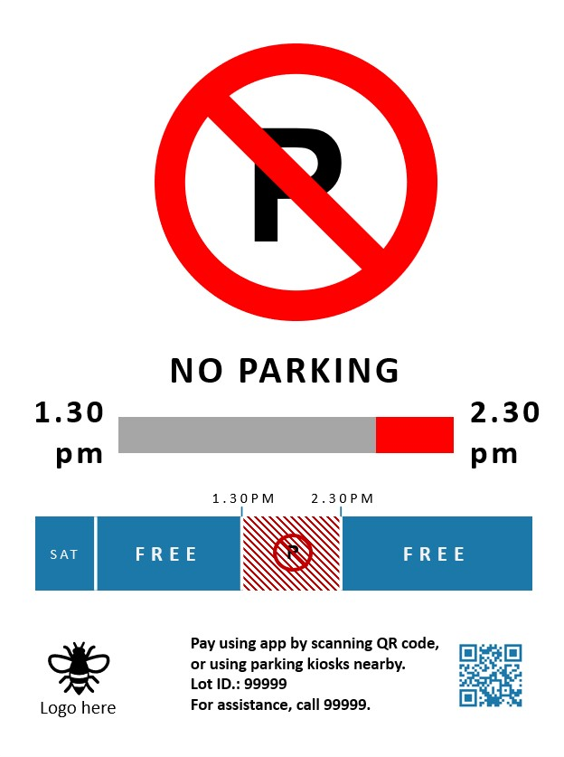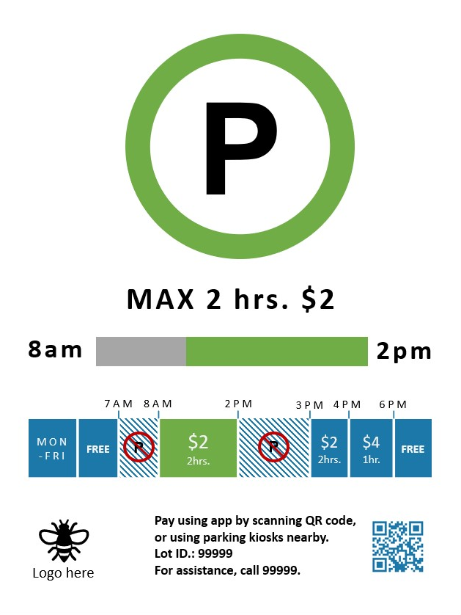

Figure 9a and 9b: Final prototype of parking signs

### **User Testing:**

### We conducted user experience surveys for both our redesigned parking sign and app.

1. Parking sign
   1. First iteration

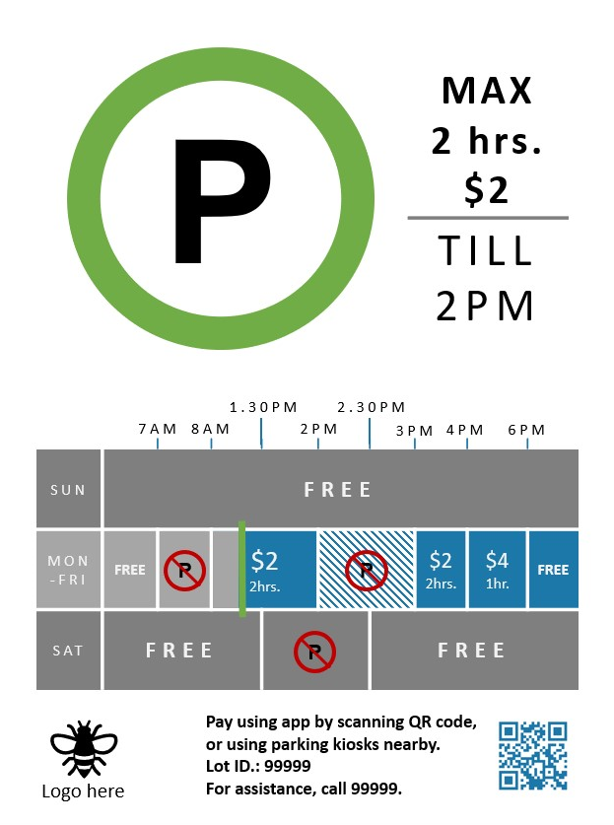

Figure 10: First iteration of our parking sign

Users commented that the sign contains too much information and the timing chart may be unclear. As the sign is to be placed at a high position, the information may be difficult to read. Nevertheless, users felt that the sign was a considerable improvement over existing parking signs. The colour scheme is simplified and dependence on colors to denote separate visual elements is avoided to reduce confusion for the visually-impaired.

* 1. Second iteration

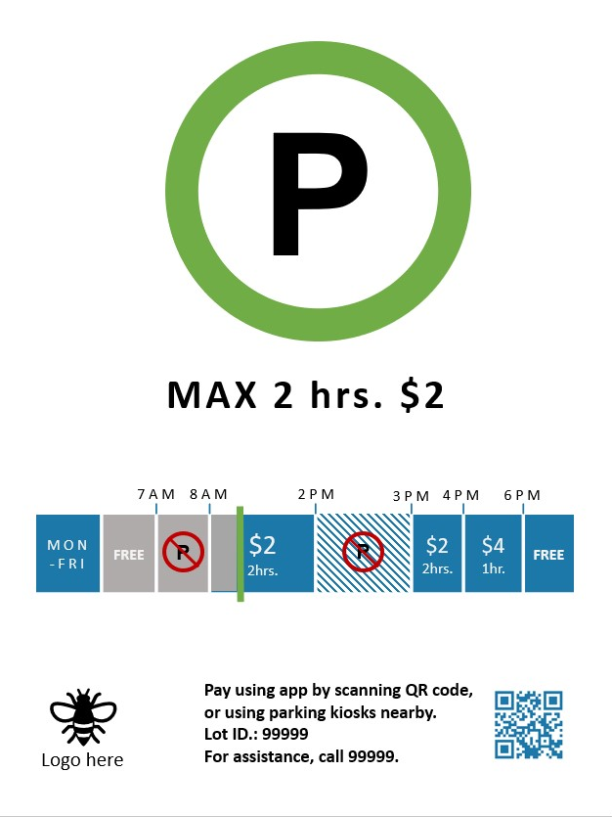

Figure 11: Second iteration of our parking sign

The second iteration minimises the essential information presented to the user. Some participants mentioned confusion at the actual parking availability of the lot with respect to the chart shown. We concluded that the “progress bar” may not be ideal at showing the current state of the parking lot.

* 1. Final iteration



Figure 11a and 11b: Final iteration of our parking signs

The final iteration provides the daily timetable of the parking slot, in addition with a clearer “progress bar” indicator. Most participants are able to read the status of the sign quickly and correctly.

Analysis of our design:

The main concept behind the design of the digital poster is to eliminate unnecessary information from existing parking signs and to present it in a manner that is simple and concise so that drivers can make parking decisions effectively, allowing them to save time.

The main features of our latest design includes:

1. Simplified colour scheme and eliminating dependence on colors to denote separate visual elements to reduce confusion for the visually-impaired.
2. Progress bar to make it intuitive for drivers to know how much time are

they allowed to park before the spot becomes unavailable.

1. Application
   1. First iteration



Figure 12: First rough iteration of application

A simple mockup is used to demonstrate basic capability to users for feedback. Participants were mostly clear about the intended use of the app.

* 1. Second iteration

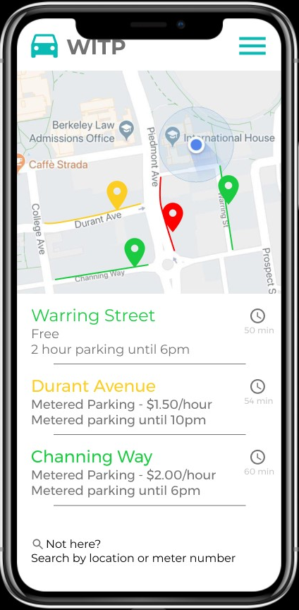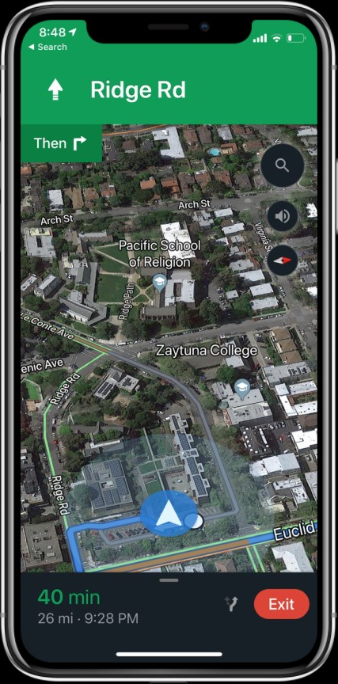

Figure 13: Second iteration of our application

A more polished prototype was made in the Figma application. User requested features such as timer integration and real-time rerouting.

* 1. Final iteration[1]

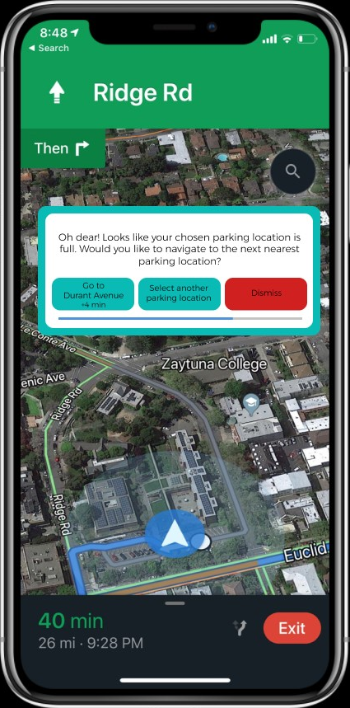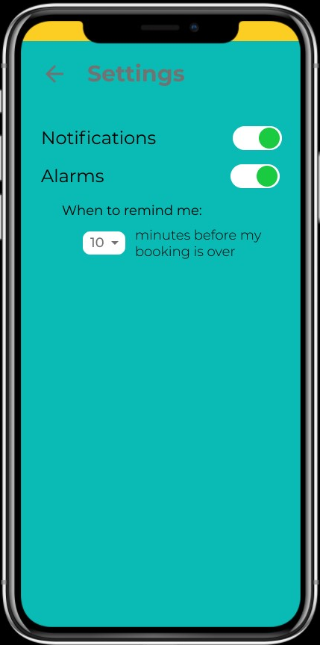

Figure 14: Final iteration of our application

User requested features were added to the prototype.

Analysis of our design:

The main concept behind the design of the mobile application is to streamline the whole parking experience by integrating the different phases of the user flow of the parking experience, from finding parking spot to paying for the spot. Just like the digital poster, we want to ensure that our user interface is simple and intuitive enough so as not to distract the driver when he uses our application.

The main features of our latest design includes:

1. Search function to allow users to see the possible parking options near their destination based on availability and price
2. Real-time monitoring of the street parking lots so as to reduce the amount of time spent to find an available street parking lot
3. Payment system that could allow flexibility in payment ie. users can choose to extend or shorten their parking time through the app and be compensated accordingly

Conclusion:

Over the rounds of user testing and feedback, we evaluated the value provided by both the app and digital signage and arrived at the conclusion to advance the app idea in favour over the digital signage.

At that state of development, the app has a feature base that far outweighs the value provided by the digital signage. In addition, the digital signage, being a hardware product, comes with a higher development and regulatory cost that could prove challenging for a small team to handle.

**Customer Journey Map:**

In order to better identify the pain points, we broke down the parking experience into 5 phases, and analysed the user’s emotions, tasks and most importantly the problems faced during each phase from finding a parking lot to paying for the parking spot.

The diagram below shows the current customer journey map, which is mainly filled with negative emotions. These negative emotions of frustrations and helplessness can be explained by 2 main reasons:

1. User does not know the street parking rules which changes according to street cleaning activities etc.
2. User does not have information on the availability of parking spaces nearby his destination.

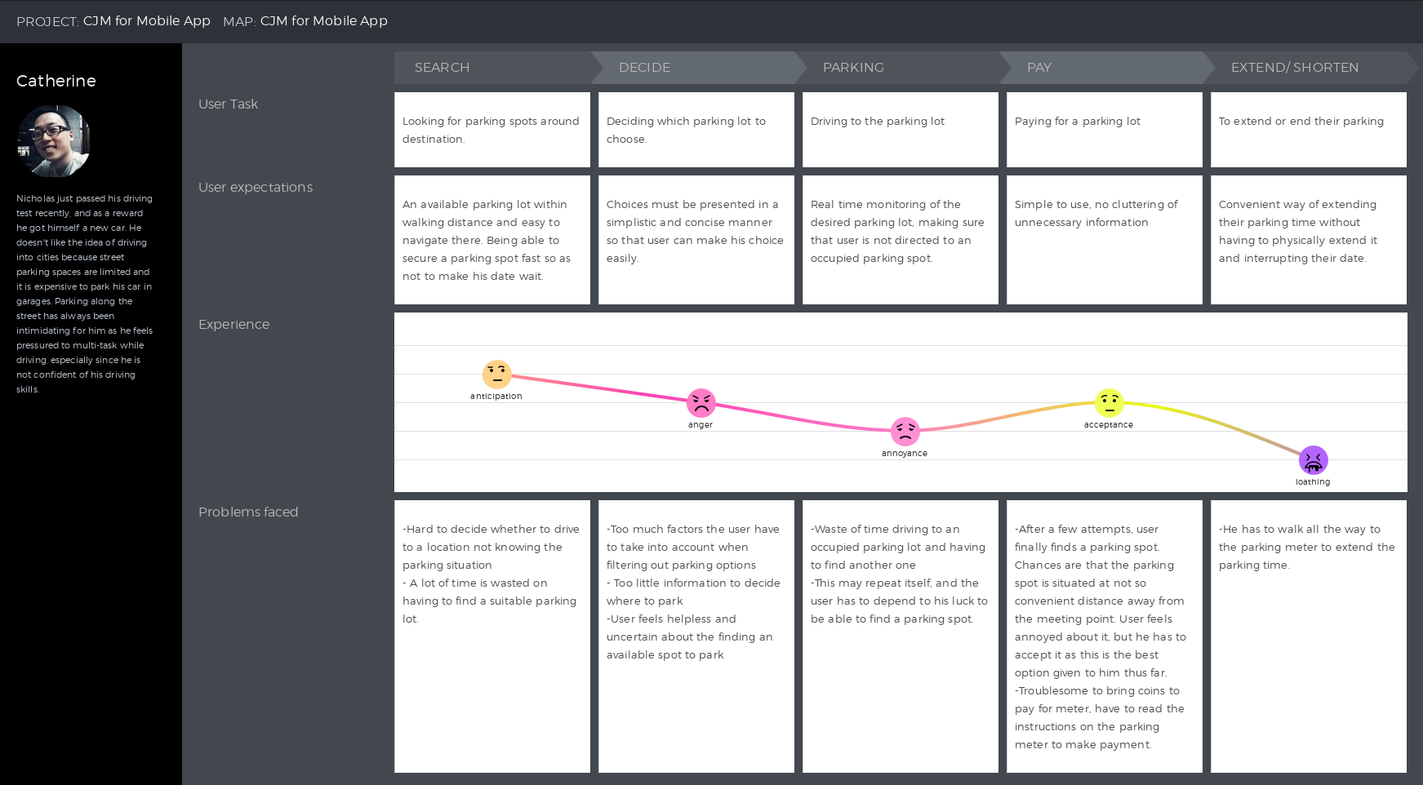

Figure 15: Journey Map describing the parking experience of a user

Our mobile application was designed with features that aim to tackle the pain points identified in diagram 1, and after the first round of surveys and user-testing, we came up with this customer journey map that captures the emotions of the user during each phase of the parking experience.

The diagram below shows the future customer journey map when users park their car using our mobile applications. As compared to diagram 1, the user does not feel frustrated nor helpless, mainly because our application aims to provide critical information that would help in their parking decisions, while recognising that it is important to make the information as succinct as possible so as not to confuse the user unnecessarily.

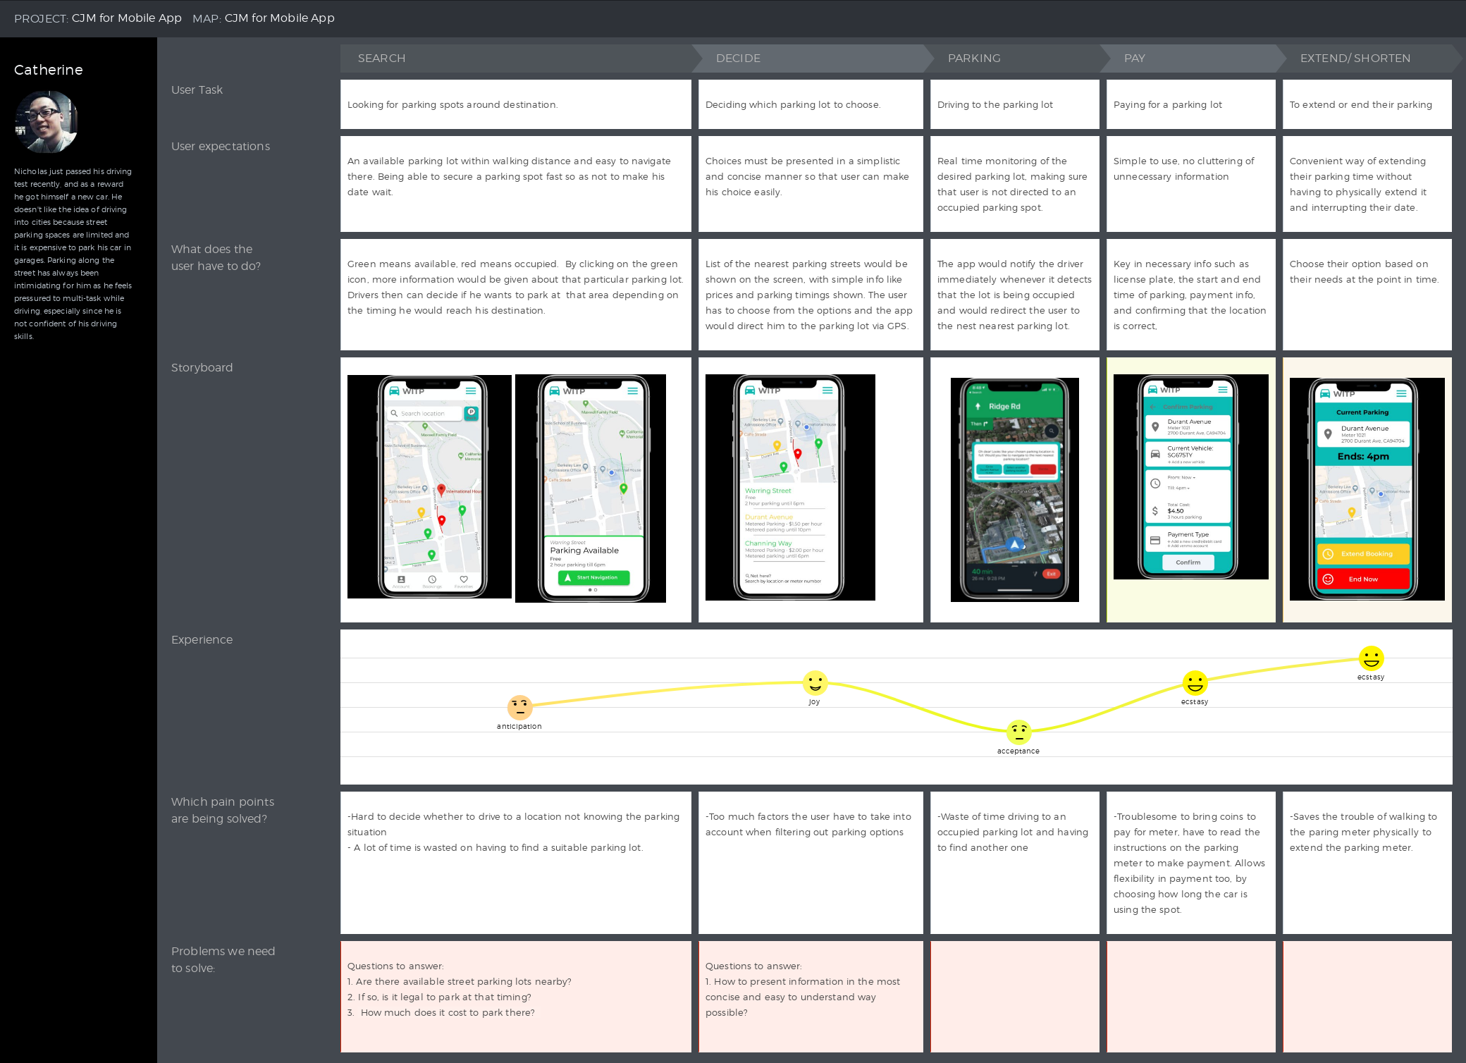

Figure 16: Journey Map describing the parking experience of a user with the help of our mobile application

### 

### 

### **Competitive Landscape:**

### After in-depth market research, we have identified the following options to aid drivers in parking in the current market:

* ParkNav
  + A phone application that shows chances of finding parking along streets by coloring the streets in their maps

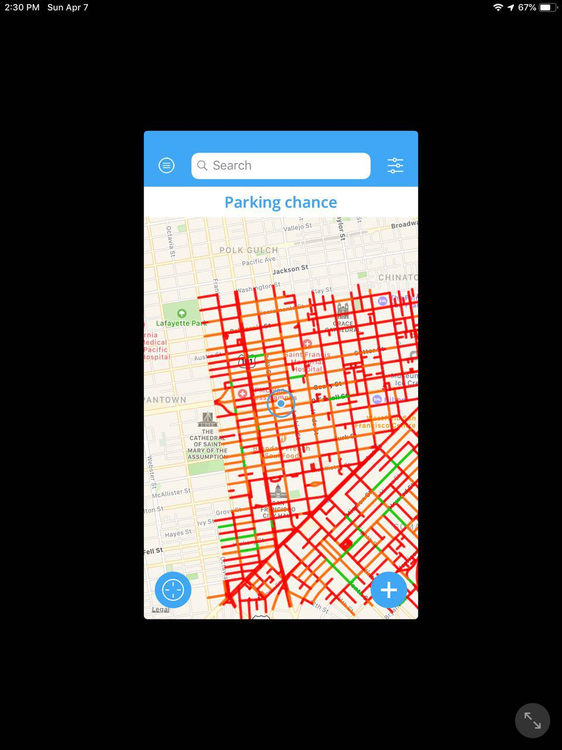

Figure 17: Screenshot of the ParkNav Application

* PayByPhone
  + The official application most meters use to pay for parking. A simple application only for payment as an alternative to using coins or a card at the meter
* SpotHero
  + A phone application that allows you to find available and reserve garage parking

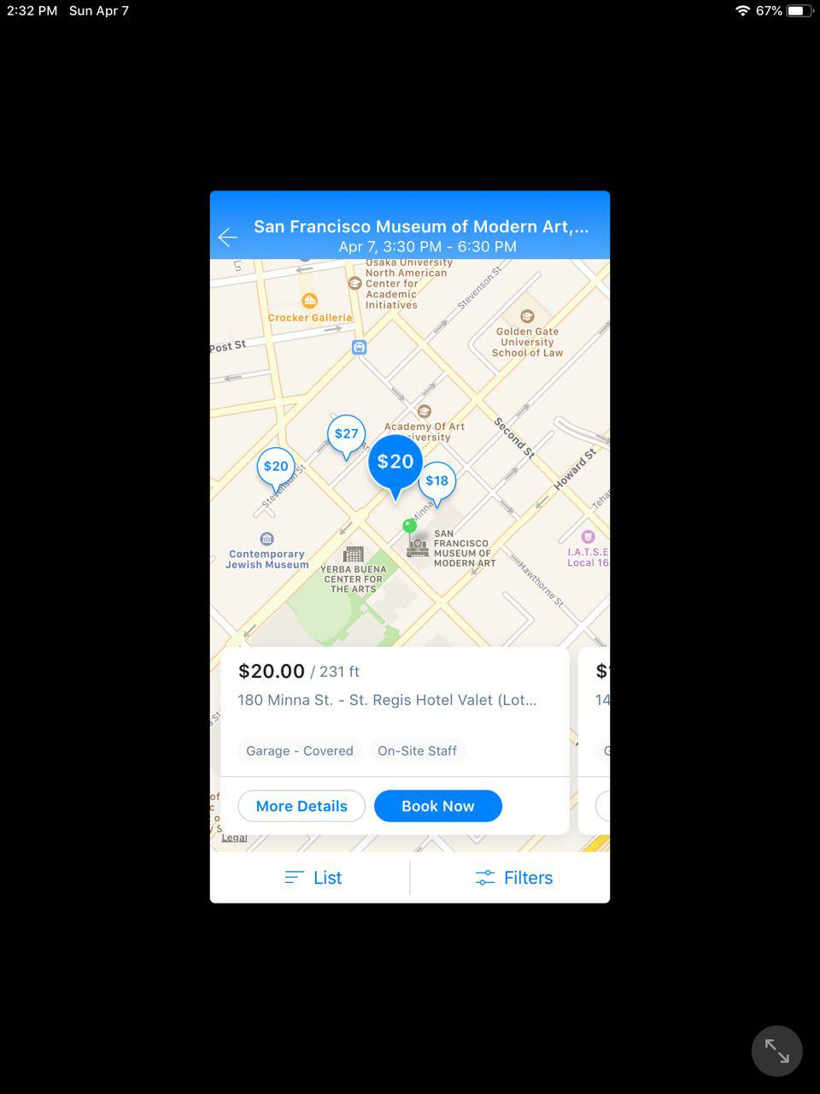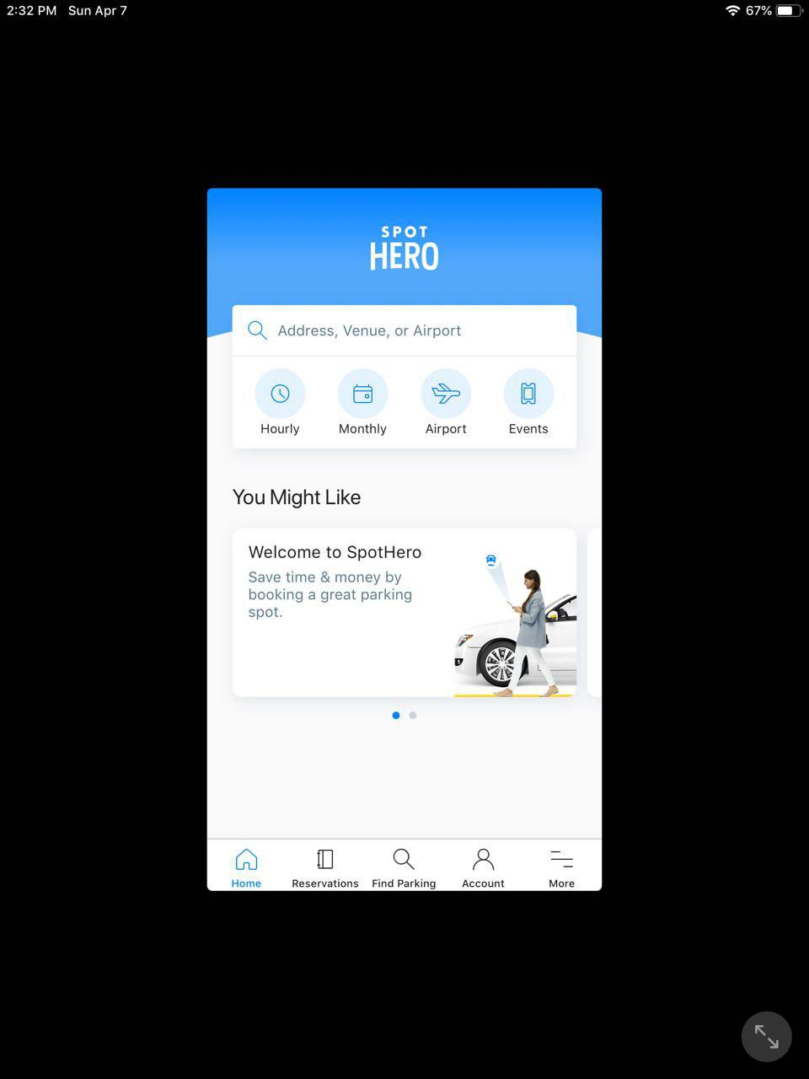

Figure 18a and 18b: Screenshots of the SpotHero Application

* SpotAngels
  + A phone application that shows available street and garage parking, as well as information about street cleaning

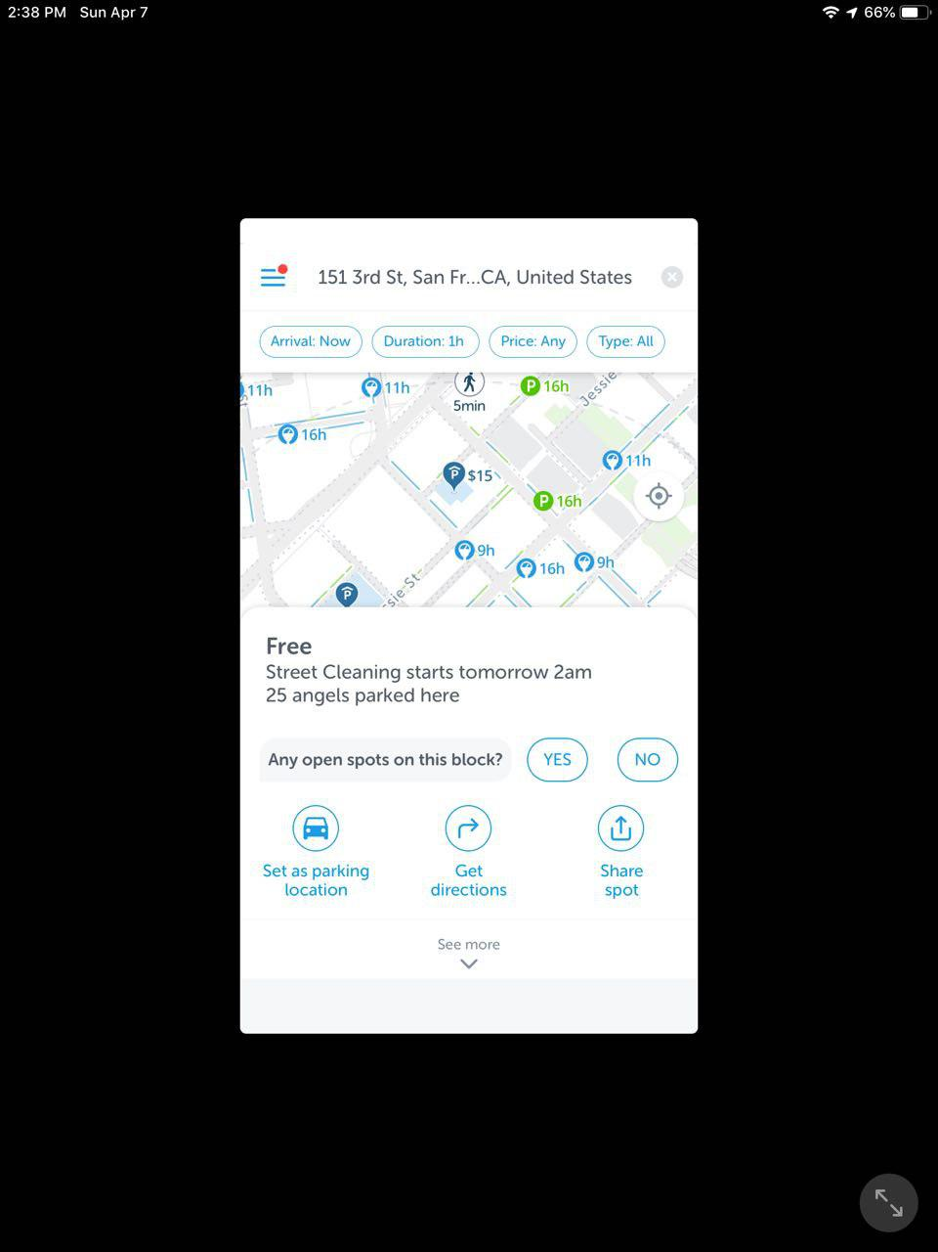

Figure 19: Screenshot of the SpotAngels Application

* More streamlined and better designed parking signs
  + A new design of parking signs have been implemented in certain parts of New York, which are less confusing than the current ones

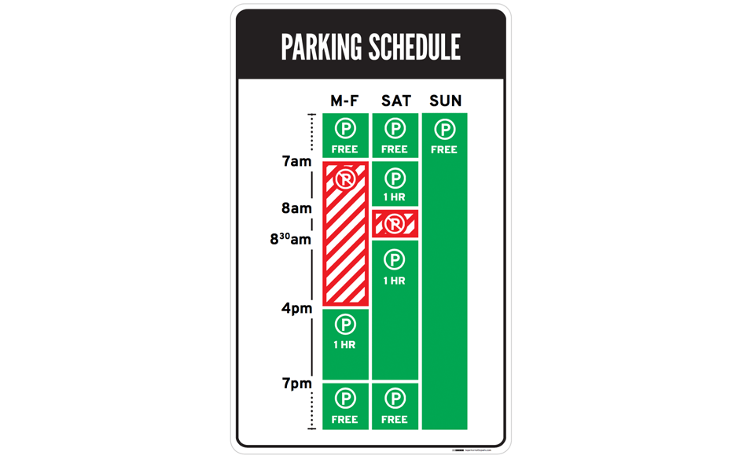

Figure 20: Nikki Sylienteng’s Parking Signs

|  |  |  |  |  |  |
| --- | --- | --- | --- | --- | --- |
| Features | PayByPhone | ParkNav | SpotHero | SpotAngels | New Signs |
| Seamless Payment | ✔️ | ❌ | ✔️ | ❌ | ❌ |
| Navigation | ❌ | ❌ | ❌ | ✔️ | ❌ |
| Availability of Street Parking | ❌ | ✔️ | ❌ | ✔️ | ❌ |
| Reserve Garage Parking | ❌ | ❌ | ✔️ | ❌ | ❌ |
| Information about lots (payment,cleaning) | ❌ | ❌ | ❌ | ✔️ | ✔️ |
| Clean UI | ✔️ | ❌ | ✔️ | ✔️ | ✔️ |

### 

### 

### **Findings from Discovery, Market & Background Research:**

### From market and background research, we found that the city of San Francisco had issued a total of around 1.5 million fines yearly. Of this number, 43% of these fines were due to street cleaning violations, an easily avoided fine if people were more informed about this information.

### We conducted surveys and spoke to drivers as well to learn more about the problem. In general, the current pain points in the parking experience is being unable to find parking easily, the confusing parking signs, unclear pricing system and being unable to estimate how long they should pay for.

**Market Validation:**

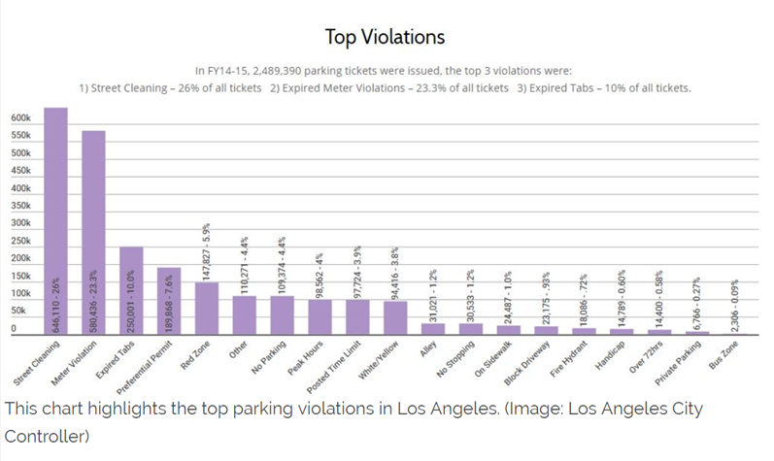

Figure 21: Statistics of parking violations in Los Angeles [2]

The diagram above shows the top violations of FY14-15 in Los Angeles. We can see that the top 3 violations were due to street cleaning activities, parking meter violations, expired tabs. Similarly, in 2015, a total of 1,365,871 parking citations were issued in San Francisco. The breakdown of the fines is as follows:

509,844 (37.3%) due to street cleaning which generated around $36 million

265,970 (19.5%) due to parking meter violations

44,182 (3.2%) were tow-away zone violations

From these statistics, we see that the most common violation is due to street cleaning activities, and assuming that drivers are rational and make reasonable decisions, the most likely reason leading to this is that drivers do not have the necessary information to decide whether they should park at a certain spot, which eventually led them to getting a fine.

This can also be corroborated by the fact that confusing parking signs makes it harder for them to make parking decisions effectively. By stopping the car to read the signs, they hog up the traffic and the thought of inconveniencing other drivers stresses them out. This hypothesis was further proven when we did conducted our survey and most of the participants agreed that this was one of the main reasons that discourages them from parking within the city.

**Market Opportunity:**

With our product, we plan to streamline and make the parking process more efficient and simple, something none of the current market options can do now. With over 500,000 cars registered in just San Francisco, there is a huge market as all drivers would need to find parking when driving. A survey we conducted showed that currently, approximately 10% of drivers currently use a phone application for parking. Most respondents also responded that if the application is able to show available parking lots, they would use it.

As such, if we estimate that 15% of drivers use our application, we would be able to obtain 75,000 users, a large market.

**Implementation (Business Model):**

As our application seeks to provide accurate real time information about available parking lots, it needs to be able to track these parking lots in an effective manner. We aim to overcome this problem by using crowdsourced information, which works better as more people subscribe to our application. As such, in order to attract large base of users initially, we want to make our mobile application free so as to encourage more users to try our application. This can also be seen as an initial round of testing, and the main focus is to collect feedback from the users to see how we can improve the application to better meet users’ needs.

In order to monetise our business, we suggest 2 main business model that this solution can possibly adopt moving forward:

1. Lead Generation - Providing collected user data to third party companies for a fee
2. Pay-per-transaction- Partner with financial services companies such as VISA or Mastercard to provide payment services. A small percentage of the parking fee would be charged.

In order to make the coverage of the mobile app more extensive, we can consider public garages that are metered (SFMTA) , and we can consider partnering private garages as well. This can potentially open us up to more revenue streams as we explore the possibility of taking a cut from the revenue of the private parking garages as well.

**Comparison with other existing products in the market:**

|  |  |  |  |  |  |
| --- | --- | --- | --- | --- | --- |
| Features | PayByPhone | SpotHero | SpotAngels | New Signs | Our Design (Walk-in-the-park) |
| Seamless Payment | ✔️ | ✔️ | ❌ | ❌ | ✔️ |
| Navigation | ❌ | ❌ | ✔️ | ❌ | ✔️ |
| Availability of Street Parking | ❌ | ❌ | ✔️ | ❌ | ✔️ |
| Reserve Garage Parking | ❌ | ✔️ | ❌ | ❌ | ✔️ |
| Information about lots (payment,cleaning) | ❌ | ❌ | ✔️ | ✔️ | ✔️ |
| Clean UI | ✔️ | ✔️ | ✔️ | ✔️ | ✔️ |

From the table above, you can see that our solution seeks to improve the whole parking experience by streamlining the user flow of parking experience by integrating the different components of the parking experience.

**Design Methodology/ Philosophy:**

The whole solution was conceived with the user experience in mind, hoping to alleviate some of the frustrations and stress experienced by drivers when parking their cars in the city.

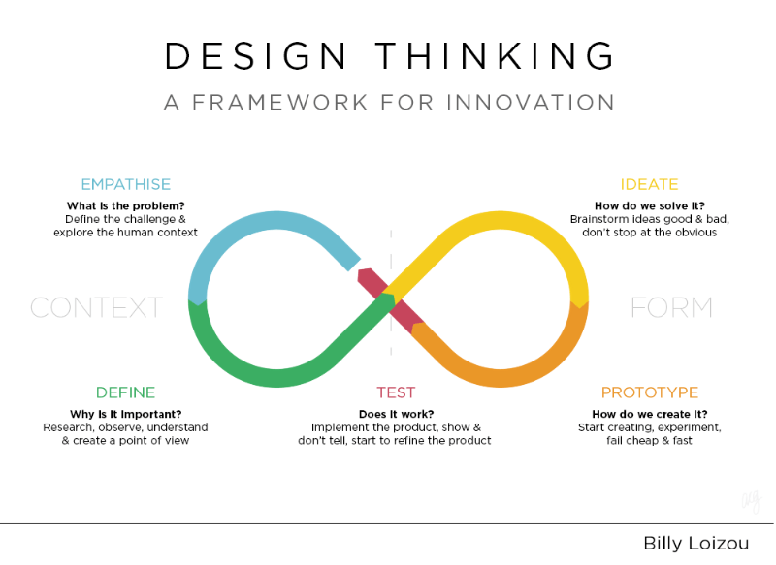

Figure 22: Design Thinking framework[3]

As described in the diagram above, our approach to this product design project can also be broken down into 5 main steps, which starts from the recognising the problem to the final stage of testing and going through iteration of the our solution.

**Step 1- Empathise**

First and foremost, we had to define a problem. Parking in Berkeley, or California in general, has always been a challenge for local drivers, and we had our first-hand experience of it during our trip to Los Angeles, where we received fines more than once for unknowingly parking along the street illegally and even had our car towed away. After conducting a brief survey, we found out that being fined for parking illegally is a common problem that has been around for a long time.

**Step 2- Define**

In order to understand why parking has been such a challenge among the local drivers, we analysed the problem and found out it can be broken down into several root causes. One of the main reasons includes people finding street parking rules complicated, and it is made worse since parking rules can also be affected by activities such as street cleaning.

Also, a customer journey map is constructed to further break down the parking experience into phases so that we can analyse each phase and come up with pain points that we want to solve through our solution.

**Step 3- Ideate**

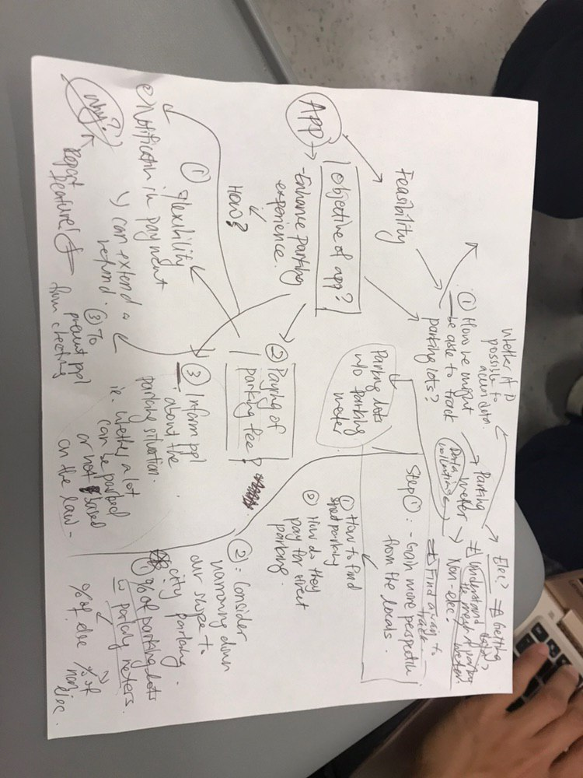

Figure 23: Idea Generation

Some of the solutions we considered were digitalizing the parking signs so that we can solve the problem of confusing parking signs by only displaying necessary time-specific information in a clear and concise manner. Another solution we came up with is the a mobile application that can streamline the experience of parking by integrating the different stages of the parking experience ie. Finding, Navigating and Paying for a parking spot into a single platform.

The picture above shows the different ideas we had for the features we wanted in the mobile application that targets different pain points which we had previously found out from the journey map of a user’s parking experience.

**Step 4- Prototype**



Figure 24: Snapshot of our figma application prototype

Since our solution is in the form of a mobile application, we used figma to design the user interface of our application. This was a quick and easy way to come up with a hi-fidelity prototype to get feedback from users so that we can use them to improve on our design.

**Step 5 - User Testing**

After creating our prototype, we did our user testing. With minimal guidance, we observed how users navigate through our application. To make our tests more realistic, we invited the user to use the application while driving, so that we can find out whether our features could solve those pain points that we originally intended for it to solve.

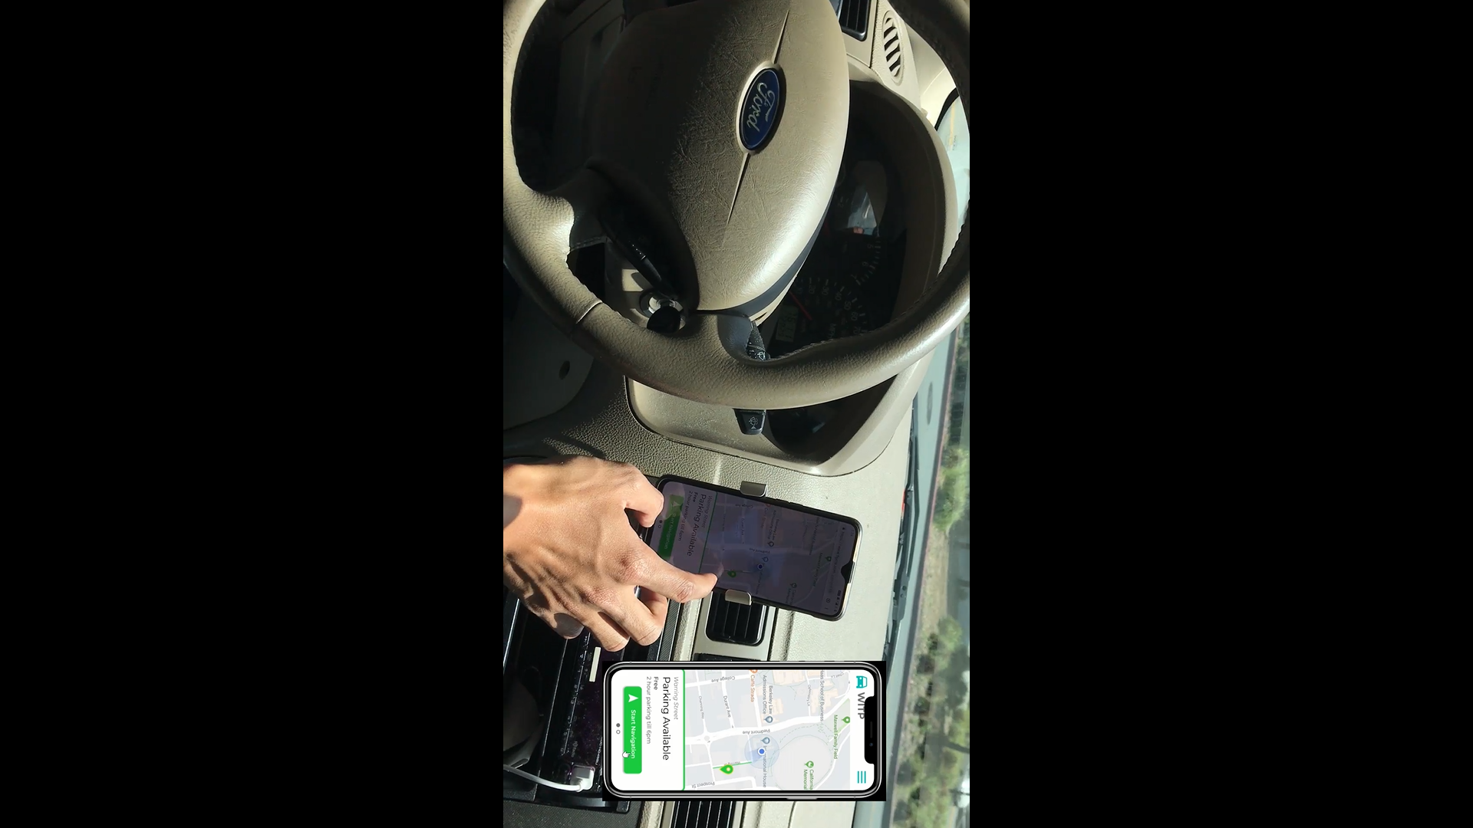

Figure 25: Snapshot of the video showing a driver using walk-in-the-PARK

Possibility of expansion

Monetising the business

Attracting large base of use

**Appendix:**

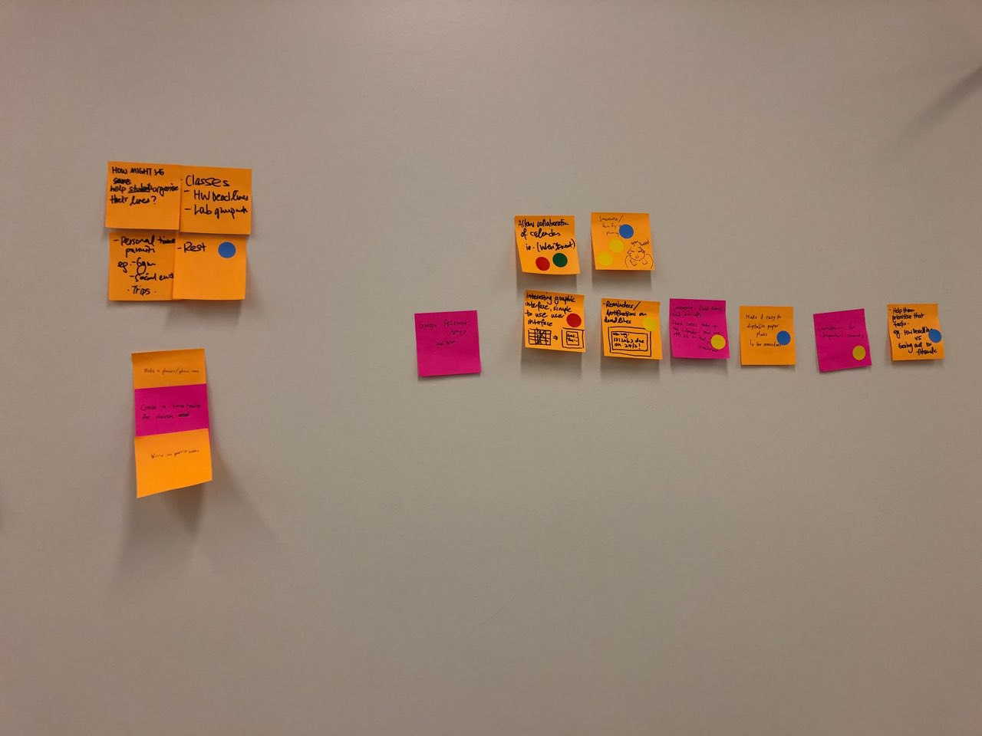

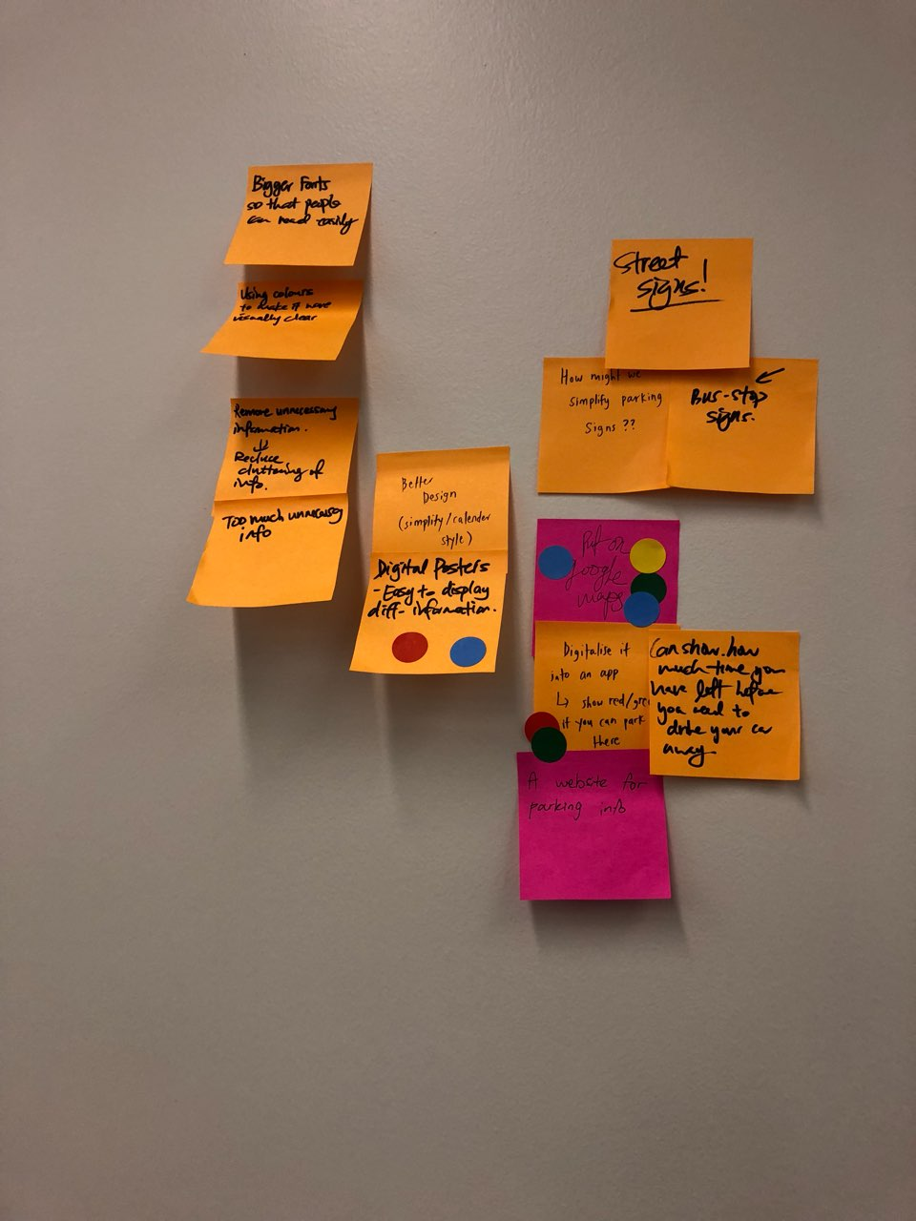

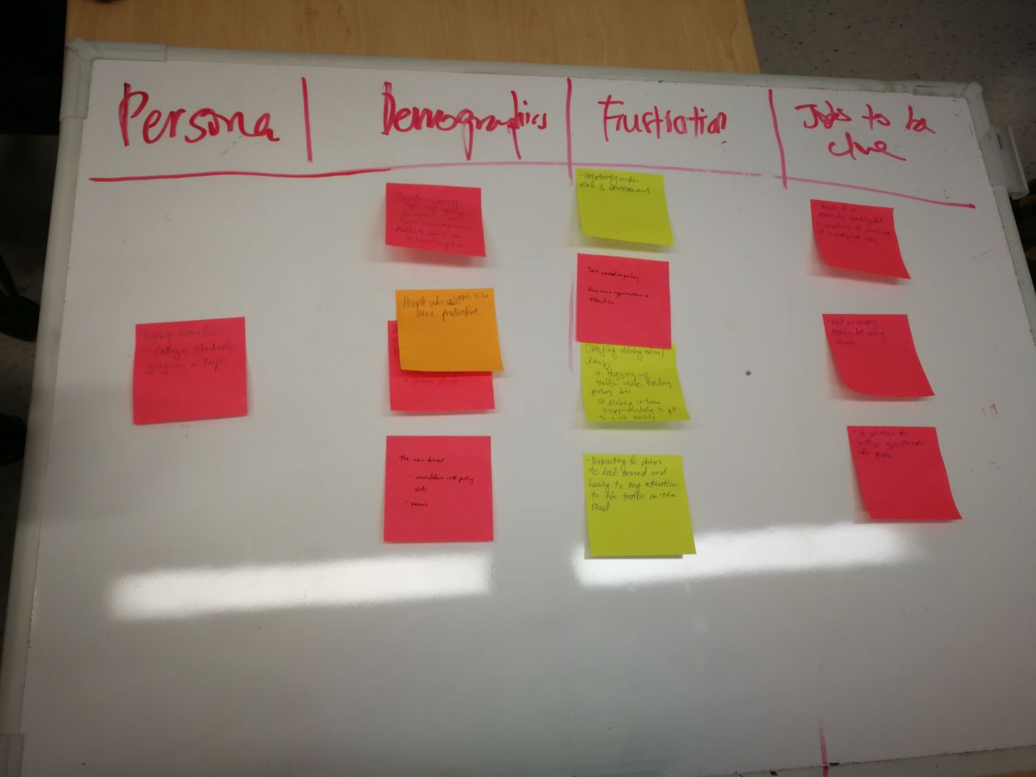

1. Link to Figma Prototype: https://www.figma.com/file/FP8JEK7jvH5I6hebBLksdfti/Product-Design?node-id=0%3A1
2. Source: https://lacontroller.org/
3. Source: https://www.hackerearth.com/blog/innovation-management/top-10-innovation-methodologies/